ETEC 644 Module 6
Chun Yi Huang

1、Describe the purpose of your formative evaluation.
Formative evaluation involves the collection of data and information during the development process that can be used to improve the effectiveness of the instruction. Formative means that the instructional materials are in their formative, or early stages, and evaluation refers to the process of gathering data to determine the strengths and weaknesses of the instruction. "Thus, formative evaluation is a judgment of the strengths and weaknesses of instruction in its developing stages, for the purposes of revising the instruction to improve its effectiveness and appeal" (Tessmer, 1997, p. 11). Formative evaluation procedures can be used throughout the design and development process. I have already formatively evaluated my materials in the process of developing them. I might lay out components on the screen, try them out, and then move them around if they are not exactly right. At this point, though, it's time to seek outside help. Even trying out instructional materials with a single learner can point out obvious flaws and lead to revisions that can have a major impact on the effectiveness of the instruction.

2、Have you already recruited your participants? Describe characteristics of one-on-one learners (selection).
One-on-one learners are probably the most utilized form of formative evaluation. In this stage, one learner at a time reviews the instructional materials with the evaluator present. The evaluator observes how the learner uses the instruction, notes the learner's comments, and poses questions to the learner during and after the instruction.
For my instructional strategies for teaching terminal objective, my goal statement will focus on ukulele chords that are the most important thing to beginner because only need to learn basic 5-10 basic chords on this website. Therefore, I already design the ukulele website and share to my ukulele teacher. Mr. Chien helped me sharing this website to his three ukulele students of beginner. Moreover, I recruited two friends who're interesting to learn ukulele. After then, I can focus on these students' feedback through questionnaires survey and discussion forum to improve my project.

3、Describe all the materials and instruments to be used in the one-on-one evaluation. Include sample question items you will use (attach surveys, interview items).

3-1、Questionnaires Survey
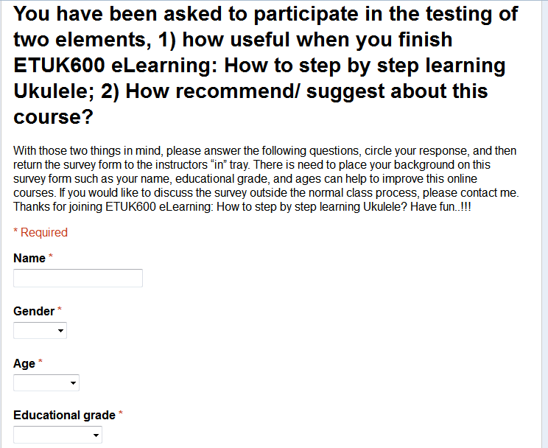
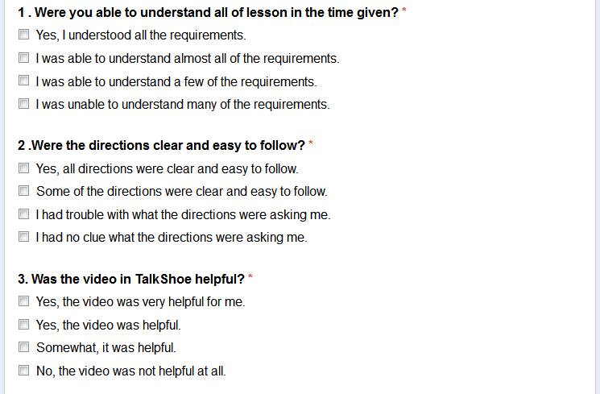
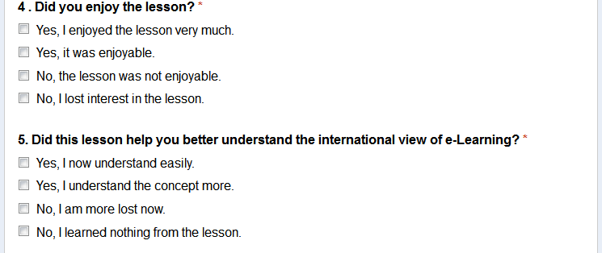
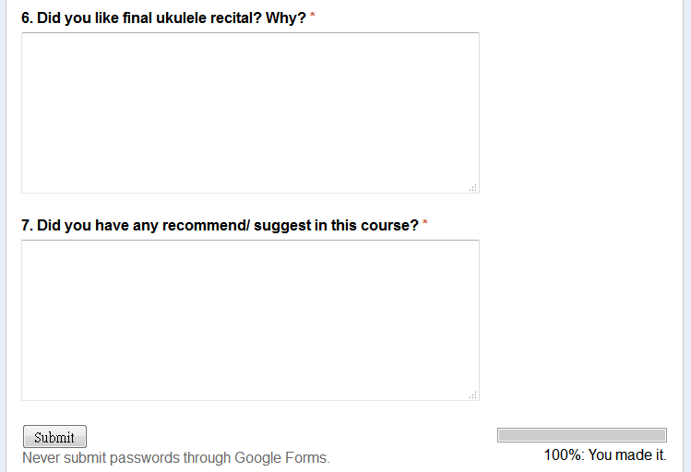
3-2、Rubistar
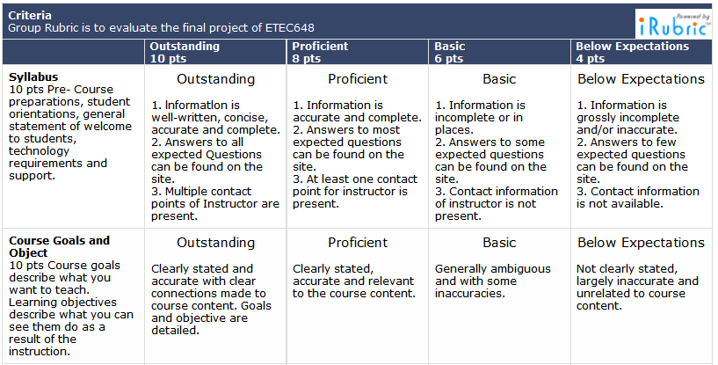

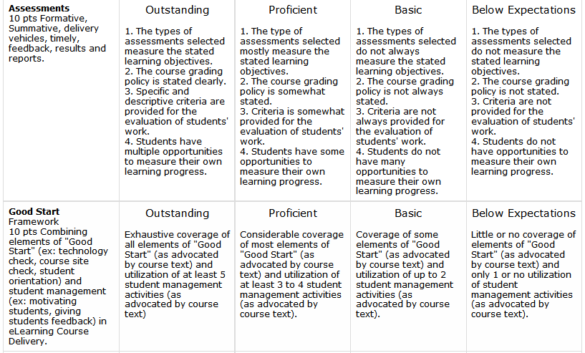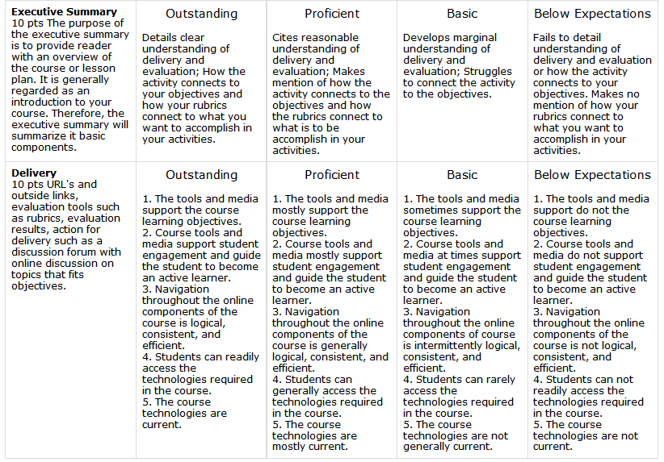

4、Describe the procedures you would use in one-on-one evaluation.
The participants will follow this procedure as below：

CHORDS
C
F
Am
G
I'm Yours

I'm Yours - Teaching Video
HOW TO STEP BY STEP LEARNING UKULELE

Contact Form
Feedback
Contact Form
Q&A

(Test)

(Questionnaires Survey/ Rubistar)
Design and Conduct Summative Evaluation

5、Describe how you are going to analyze and present your data.
According to Dick, Carey, and Carey, I will focus on this three phase to analyze and present my data：
1) Review and analyze the data to develop recommendations for improving the effectiveness of the instruction based on the learner's viewpoint.
2) Revise the instruction if needed.
3) Repeat the evaluation using different learners. It is recommended that three learners be evaluated to validate corrective actions stated in the recommendations.

References
Tessmer, M. (1997). Planning and conducting formative evaluations. London: Kogan Page.
Dick, W., Carey, L. & Carey, J. (2014). The Systematic Design of Instruction With Pearson Etext -- Access Card. City: Pearson College Div.

