Design Documents
Chun Yi Huang
ETEC 644, Section 01
California State University San Bernardino
May 14, 2014

Website Navigation Menu
HOW TO STEP BY STEP LEARNING UKULELE
HOME
ABOUT
HISTORY
TUNER
CHORDS
GUIDES
PAYPAL
CONTACT

Focus on basic 5-10 basic chords
According to Dr. Beak suggested that it looks like you communicated with your target audience but it does not offer a clear description about how you collected the data (interview, survey) and what you did ask. Therefore, I revised this course will delivery for this quarter consisted of the following: a Good Start Plan and the online discussion activity. My delivery consist of a welcome email message, a course syllabus, a course schedule, a student profile sheet, a student handout, an evaluation questionnaire survey, and an online discussion post assignment. Evaluation of the learners was completed through course rubric, questionnaire survey, and formative and summative assessments. In the end of the course I will have a pre- and post-tests (the quiz will in the last class and its one of the important evaluation in my course).
Ukulele Learning website can not only assist beginners no matter real audience or online students. Moreover, it can also be a good start for people who plan to learn guitar or other musical instruments in the future. As for my long-term goal, I want to by providing a platform for ukulele instructors design different level programs (payment) for future potential advanced learners.
To myself it seems that the five key concepts are teach in a natural environment, define learning objectives, focus on your objectives, the power of testing, and lastly have fun.
1) Three Types of Interaction (learner-content, Learner-instructor, and learner-learner)：
It is very important to have all 3 types of interaction in an online class. In a face to face class the instructor can monitor each student’s progress and adjust the instruction if necessary. In an online class it is much harder. When developing the course it is essential to incorporate ways in which students are expected to learn the content they are being taught. Learner-Content interaction is the results from students examining/ studying the course content and from participating in class activities. Learner- Instructor interaction is responsible for stimulating and continuously maintaining the learner’s interest in the topic and motivating the student to learn. Learner-Learner interaction happens between the learners of an online environment with or without the real-time presence of the instructor. There is communication amongst classmates via online, chat or blog.
2) Absorb, Do, and Connect Activities：
It is important to choose the correct type of activity for the lesson you are trying to teach. Choosing the correct activity will all depend on what you want the students to learn from the lesson. If the purpose is for students to absorb the information (whether it’s a PowerPoint presentation, lecture notes, reading assignment) then an absorb activity can help in achieving this goal. If the lesson requires students to do an activity based on the readings (whether it’s a worksheet with questions, visiting a website for extra readings etc.) then an instructor should incorporate do type of activities. Connect type of activities can be used if the instructor wants the students to connect what they are learning to what they already know. Essentially, all three are recommended to understand a lesson.
3) Media：
The selection of media is very important because you want to choose the correct media for the lesson you are trying to develop. The media should match the activities that are going to be given. Before determining what type of media to use, an instructor should first identify what he or she wants the student to achieve and then select media that will support that goal. The use of media will assist tremendously in a student’s learning.
4) Mobile Learning：
Mobile learning is a new type of media that allows a person to learn at any time and any place while using portable electronics such as smartphones, I pads, tablets, kindle, IPods or any device an internet.) Mobile learning can be used to engage and expose learners to a variety of mobile technologies that will help them with their learning. With mobile learning becoming so popular I can predict it being used more in future eLearning environments.
5) Tests：
An instructor can test a student’s understanding of the material to determine if they need assistance or if they have mastered the lesson. A test doesn’t necessarily mean a final exam that a student must take to determine what they have learned throughout the whole lesson. A test can indicate how well learners meet learning objectives. There are many types of tests an instructor can use to evaluate a student’s progress. To determine what type of test to use, and instructor must first determine the purpose for testing.
First of all, when you decided to join us, you should be reviewed as soon as possible on my website: HOW TO LEARN UKU STEP BY STEP which was help you to be more aware of this course. I sent a welcome email and syllabus for all students in this online course. The discussion was using by posting on the contact forum in the website. Before you posting please following the Student Handout: Guidelines for online discussion. Moreover, there are including my course rubric and questionnaire survey in the design of my website. Also the rubric can be found on the rubistar website that was evaluating ETEC 644 final project. In the end of the course I will have a quiz (the quiz will in the last class and its one of the important evaluation in my course).
Describe instructional sequence/ Instructional content structure (flowchart)
CHORDS
C
F
Am
G
I'm Yours
(Test)
I'm Yours - Teaching Video
HOW TO STEP BY STEP LEARNING UKULELE

Contact Form
Feedback
Contact Form
Q&A

For my instructional strategies for teaching terminal objective, my goal statement will focus on ukulele chords that are the most important thing to beginner because only need to learn basic 5-10 basic chords on this website. After then they can play more than 10 songs by these basic chords. Finally, I will provide a platform for ukulele instructors design different level programs (payment) for you learning advanced ukulele lessons.

VI、Describe student groupings and media selections
VII、Attach copies of pre- and post-tests to be used with the instruction
VIII、Summary: Thorough discussion of what your design means in terms of potential development of your project and what key factors must be addressed.

IX、Timeline for development (Template provided)

Storyboard - HOW TO LEARN UKU STEP BY STEP
1、
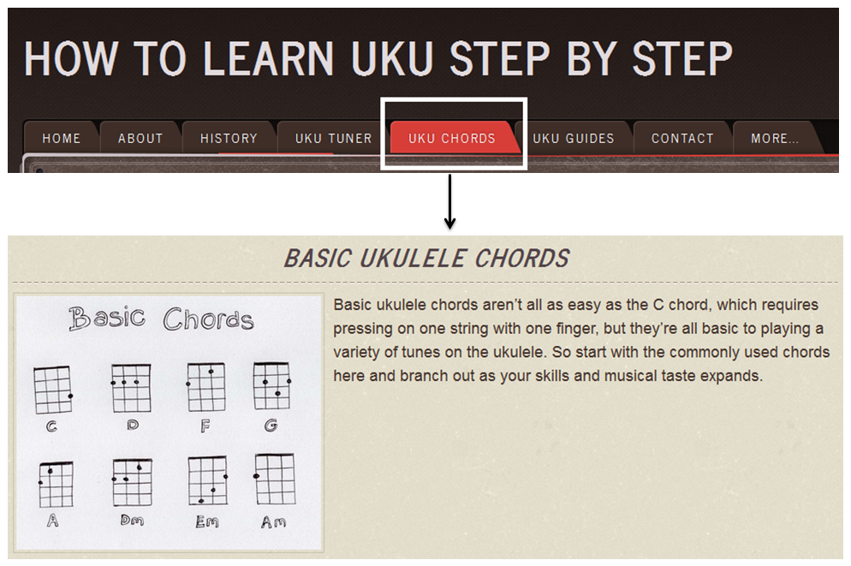
2、
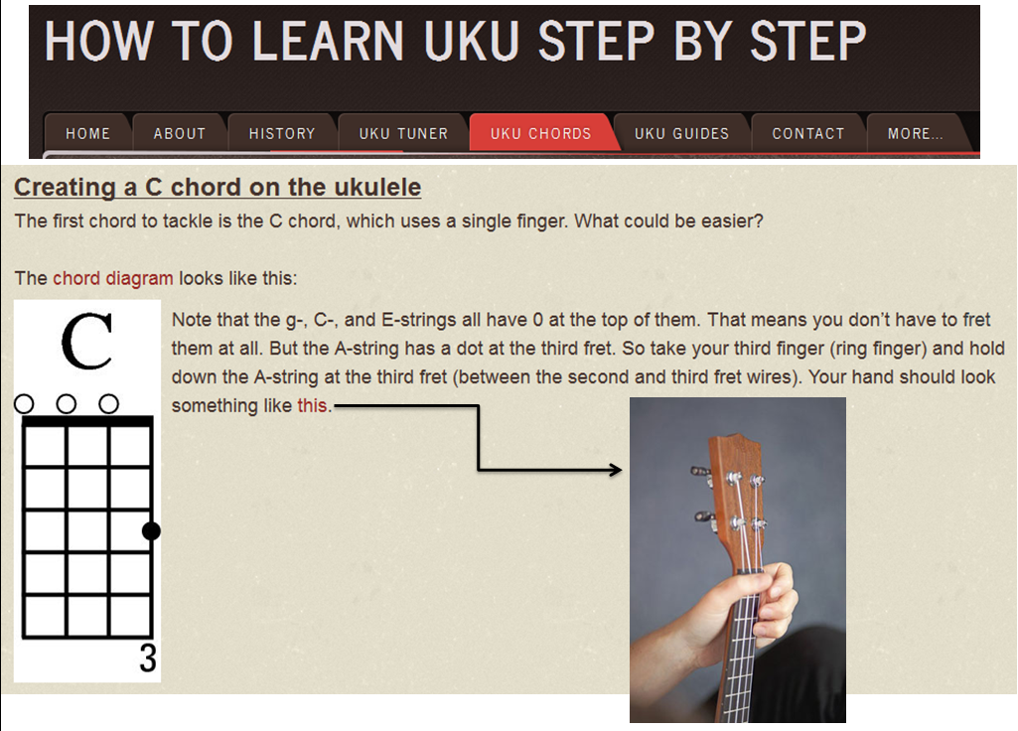
3、
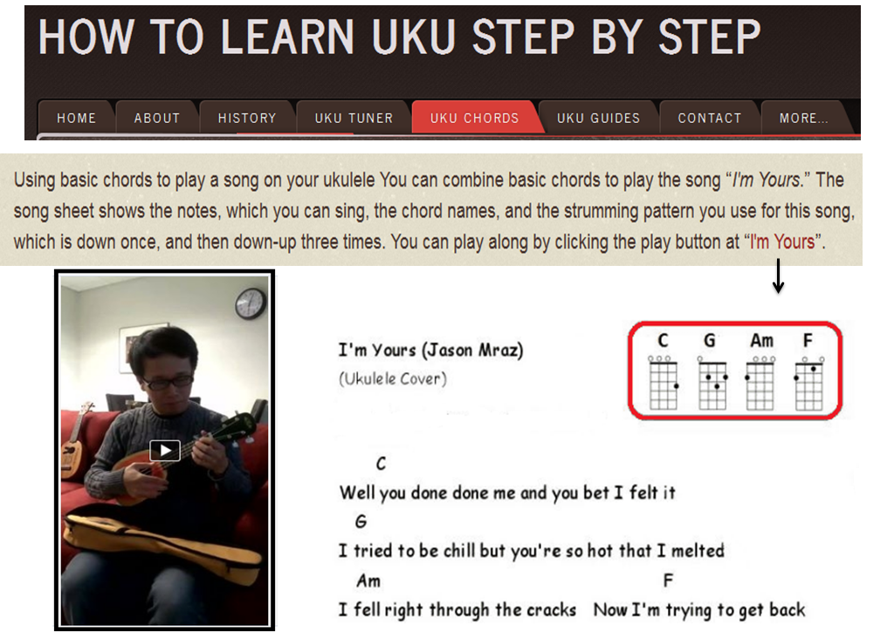
4、
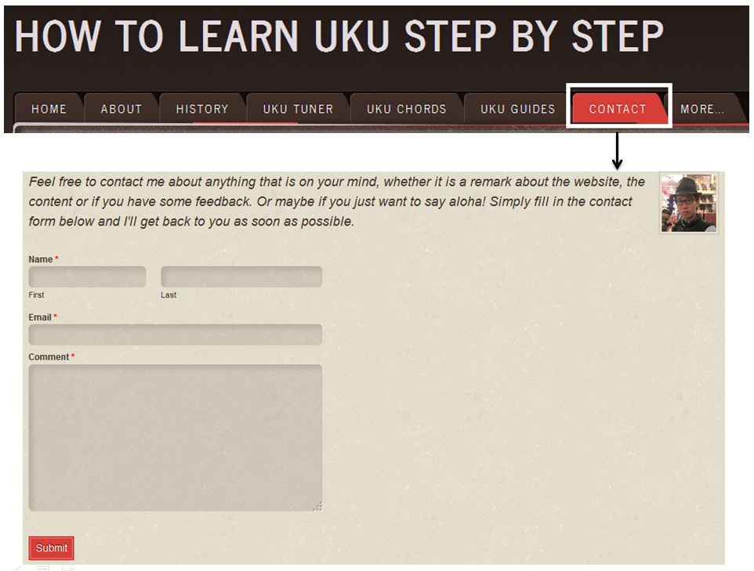

Ukulele instructor will give to 3-5 beginner testing and I'm going to focus on these students. Through questionnaires analyze and offer their opinion to improve my project. Moreover, it can also be a good start for people who plan to learn guitar or other musical instruments in the future. As for my long-term goal, I want to by providing a platform for ukulele instructors design different level programs (payment) for future Potential advanced learners.
For years, the ukulele had been labeled a toy instrument never to be taken seriously. Today, Ukulele underground continues to challenge the world’s preconceived notions of what the ukulele is supposed to sound like and break barriers that limit the types of music the ukulele is associated.
1、Limited time
2、Instructional design issues
3、The network information error
4、Textbooks unable to meet student needs
Therefore, I will be addressed these key factors by my ukulele website and courses design. I have conduct the internet search to look for instructional materials that are already available to address the instructional problem including strengths and weaknesses of these materials. After analysis of an instructional design problem and combine with my design means in terms of potential development of my project. I will follow identify five key concepts related to our eLearning design and development. It is very important to have all three types of interaction (learner-content, Learner-instructor, and learner-learner) in an online class. In a face to face class the instructor can monitor each student’s progress and adjust the instruction if necessary. In an online class it is much harder. When developing the course it is essential to incorporate ways in which students are expected to learn the content they are being taught. Learner-Content interaction is the results from students examining/ studying the course content and from participating in class activities. Learner- Instructor interaction is responsible for stimulating and continuously maintaining the learner’s interest in the topic and motivating the student to learn. Learner-Learner interaction happens between the learners of an online environment with or without the real-time presence of the instructor. There is communication amongst classmates via online, chat or blog.
Moreover, It is important to choose the correct type of activity for the lesson you are trying to teach. Choosing the correct activity will all depend on what you want the students to learn from the lesson. If the purpose is for students to absorb the information (whether it’s a PowerPoint presentation, lecture notes, reading assignment) then an absorb activity can help in achieving this goal. If the lesson requires students to do an activity based on the readings (whether it’s a worksheet with questions, visiting a website for extra readings etc.) then an instructor should incorporate do type of activities. Connect type of activities can be used if the instructor wants the students to connect what they are learning to what they already know. Instructional Design is a systematic and systemic process for the creation of educational resources. It is often viewed as a "problem solving" process. For the reason that I will use ADDIE design model to support my instructional design. The ADDIE instructional design model consists of Analysis, Design, Development, Implementation, and Evaluation. The general idea is to go down the list, but there will be occasions where one will jump from step to step to create an effective course. The first step in using the ADDIE model to create an online course is to analyze the data and what is being asked of the developer. This includes research, data collection, and beginning to lay the blueprint of what is needed to be effective. In order for the needs of the instructor and the students to be met, the developer must address them here before designing the course. For an online course in physical education, the developer must first obtain the course objectives, goals set forth by the instructor, and the needs of the students. Web Design part, I'm going to use HTML5, CSS JavaScript, Flash etc. technologies to improve this online class.

References
Dick, W., Carey, L. & Carey, J. (2015). Systematic Design of Instruction, (8th ed.)
Upper Saddle River, NJ: Pearson.
Anonymous, . (2010). Ukulele products. Musical Merchandise Review, 169(10), 34.
Cervine, D. (2010). The ukulele. Atlanta Review : AR, 17(1), 50.
Chomphan, S. (2012). Pitch analysis of ukulele. American Journal of Applied Sciences, 9(8), 1219-1224.
Foster, L. (2013). The 'ukulele: A history. Choice, 50(9), 1636.
Greenberg, M. (2002). The ukulele in your classroom. Music Educators Journal, 79(3), 43-48.
Williams, G. (2009). Absolute beginners ukulele. Library Journal, 134(9), 79.

